

**Recep Tayyip Erdogan University**

**Faculty of Engineering and Architecture**

**Computer Engineering**

CE103- Algorithms and Programming I

**Project-1 (Week-4)**

**Fall Semester, 2020-2021**

| Instructor | Asst. Prof. Dr. Uğur CORUH |
| --- | --- |
| Contact Information | [ugur.coruh@erdogan.edu.tr](mailto:ugur.coruh@erdogan.edu.tr) |
| Google Classroom Code | **ouw44uk** |
| Publish Date | **04.11.2020** |
| Due Date | **01.12.2020 17:00** |

**Complete the following homework requirements, prepare them in the format given in the link below until the deadline and time, and upload them to the related assignment in the classroom.**

<https://drive.google.com/file/d/1yqSXZZ3346iIqotb_e_yzaryfxEXE0fR/view?usp=sharing>

**Grades:**

| Problem-1 | 100 points |
| --- | --- |
| **Total** | **100** points |

*You will develop the following examples in C language. The examples with C ++ will not be accepted.*

NOTE: In the code, add the following information with printf. Put the description of each application in the problem part.

int main**(**void**)**

**{**

printf**(**"Build Time: %s %s\n"**,** __DATE__**,** __TIME__**);**

printf**(**"Owner: Name Surname\n"**);**

printf**(**"Student ID: 11111111\n"**);**

printf**(**"Course: CE-103\n"**);**

printf**(**"Homework: 1\n"**);**

printf**(**"Problem: “Printing the Text Entered on the Screen in Reverse \n"**);**

**...** your codes**...**

**}**

**Problem-1**: *Build and Port Data Management System (100 points)*

In the following link you will see 50 interesting programming c projects. Your objective is use “10-Medical Store Management” application code-base and create “6. Departmental Store Management” application. You wil port an application code-base for different bussiness requirements.

Webpage : <https://learnprogramo.com/50-interesting-programming-c-projects-download-with-source-code/>

***6. Departmental Store Management.***

*The Departmental Store Management System is a console-based application built using c language which does not use graphic. This application can be used in any departmental store where you can add the goods, edit goods,search, delete, and also display the data of goods.*

*This project also uses the method of file handling where you can store all the goods data like rate, product name and price in a specific file. The data is stored in the file so you can display the data stored in that file anytime. In this project void****gotoxy(int x, int y)****is used. This function allows the user to print text in any place of the screen.So we have not mentioned the source code because of its length. To download source code you can directly click on the download button just below the below image.*

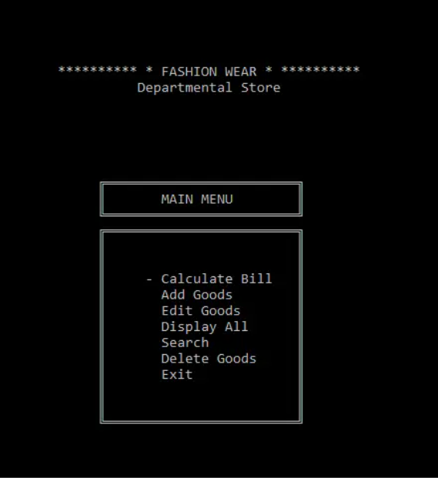

[Download](https://learnprogramo.com/wp-content/uploads/2020/04/DEPARTMENTAL-STORE-PROJECT-IN-C.zip)

***10. Medical Store Management.***

*With the help of Medical Store Management System Project, you can perform operations like insert, delete and modify the records of customers, medicine and the suppliers which is added into the stock. This project is a console-based application without graphics. The source code of this project is very lengthy and totally error-free which is designed and compiled in Code:: Block IDE with the help of MinGW compiler. This project is very comprehensive because the method of file handling is used extensively to store the data in a particular file. The use of Data Structure is also done for storing and organizing the data. To understand better download and compile the project. The download button is given just below the image.*

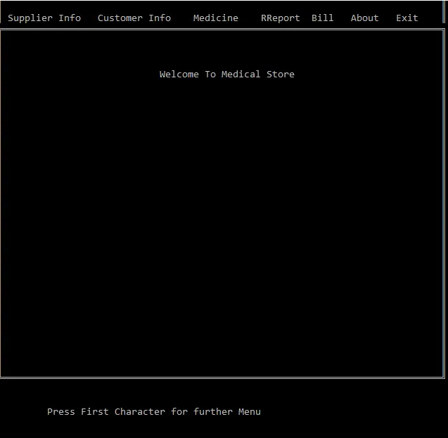

[Download](https://learnprogramo.com/wp-content/uploads/2020/04/MEDICAL-STORE-MANAGEMENT-IN-C.zip)